A04-1 Research group
Title Times 14pt

Name, Institution Times 12pt Taro Matsuyama, Ehime Univ.
Jiro Iyo, Ehime Univ.

- Introduction
Main text Times 11pt, up to 2 pages
“The mineral of Ehime prefecture” is stibnite [1]………………..

- Methods
……………………
…………………….

- Results and discussion
Results obtained in this study are shown in Fig. 1…………………
…………………….
…………………….

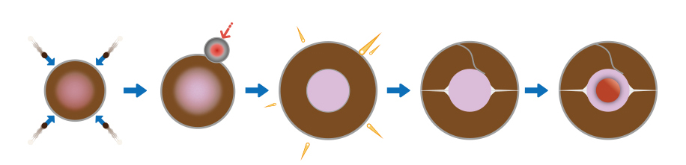
Fig. 1: Earth’s evolution

- Conclusions
…………………….
…………………….

References
- T. Matsuyama, J. Iyo, S. Ozu, and S. Toon, Study on stibnite, Mineralogy. 1, 110-120 (2019).
- T. Matsuyama and J. Iyo, Study on the core. Geophysics, 2, 10-13 (2019).

